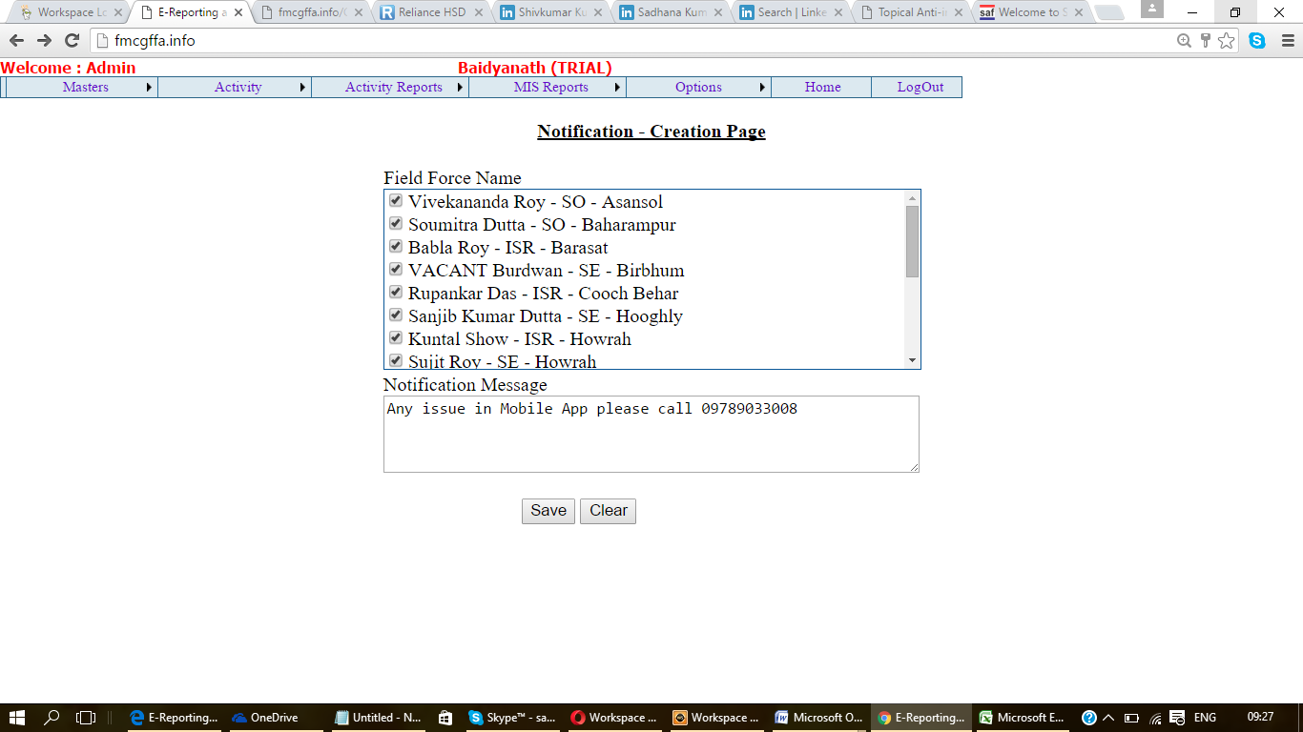

Microsoft OLE DB Provider for SQL Server error '80040e14'
Column name or number of supplied values does not match table definition.
/Sfm/IncFiles/DBOperation.inc, line 104

